UCS645: PARALLEL & DISTRIBUTED COMPUTING
Assignment 2
KETANPREET SINGH(102303386)
Submitted to SAIF NALBAND
Question 1: Molecular Dynamics - Force Calculation Problem: Implement parallel computation of Lennard-Jones potential forces in a molecular dynamics simulation. Given N particles in 3D space, calculate the total potential energy and forces acting on each particle. Tasks
- Parallelize the nested loops using OpenMP
- Handle race conditions in force accumulation
- Implement reduction for total energy
- Optimize load balancing 5. Add performance measurement

Solution :
#include <iostream> #include <vector> #include <cmath> #include <omp.h> #include <iomanip>

using namespace std;

struct Particle { double x, y, z;
};

int main() {

int N = 4000; // Increase workload for better scaling double epsilon = 1.0;

vector<Particle> particles(N);

// Initialize positions

for (int i = 0; i < N; i++) { particles[i].x = drand48(); particles[i].y = drand48(); particles[i].z = drand48();
}

int max_threads = omp_get_max_threads();

cout << "Optimized Lennard-Jones Simulation\n"; cout << "Particles: " << N << endl;
cout << "Max Threads: " << max_threads << endl;

cout << " \n";

double T1 = 0.0;

cout << left << setw(10) << "Threads"

<< setw(15) << "Time(s)"

<< setw(15) << "Speedup"

<< setw(15) << "Efficiency"

<< endl;

cout << " \n";

for (int threads = 1; threads <= max_threads; threads *= 2) {

omp_set_num_threads(threads);

// Global force arrays vector<double> fx(N, 0.0);
vector<double> fy(N, 0.0);

vector<double> fz(N, 0.0);

double total_energy = 0.0;

double start = omp_get_wtime();

#pragma omp parallel reduction(+:total_energy)

{

int tid = omp_get_thread_num();

// Thread-local force arrays vector<double> fx_local(N, 0.0);
vector<double> fy_local(N, 0.0);

vector<double> fz_local(N, 0.0);

#pragma omp for schedule(dynamic)

for (int i = 0; i < N; i++) {

for (int j = i + 1; j < N; j++) {

double dx = particles[i].x - particles[j].x; double dy = particles[i].y - particles[j].y; double dz = particles[i].z - particles[j].z;

double r2 = dx*dx + dy*dy + dz*dz + 1e-12;
double inv_r2 = 1.0 / r2;

double inv_r6 = inv_r2 * inv_r2 * inv_r2; double inv_r12 = inv_r6 * inv_r6;

double potential = 4 * epsilon * (inv_r12 - inv_r6); total_energy += potential;

double force_scalar =

24 * epsilon * (2*inv_r12 - inv_r6) * inv_r2;

double fx_val = force_scalar * dx; double fy_val = force_scalar * dy; double fz_val = force_scalar * dz;

// Update thread-local forces fx_local[i] += fx_val; fy_local[i] += fy_val; fz_local[i] += fz_val;

fx_local[j] -= fx_val; fy_local[j] -= fy_val; fz_local[j] -= fz_val;
}
}

// Merge local forces into global forces #pragma omp critical
{

for (int i = 0; i < N; i++) { fx[i] += fx_local[i]; fy[i] += fy_local[i]; fz[i] += fz_local[i];
}

}

}

double end = omp_get_wtime(); double Tp = end - start;

if (threads == 1) T1 = Tp;

double speedup = T1 / Tp;

double efficiency = speedup / threads;

cout << left << setw(10) << threads
<< setw(15) << Tp

<< setw(15) << speedup

<< setw(15) << efficiency

<< endl;

}

return 0;

}

Tables of results :
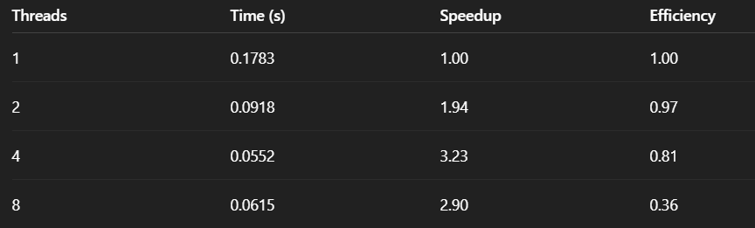

Graphs :
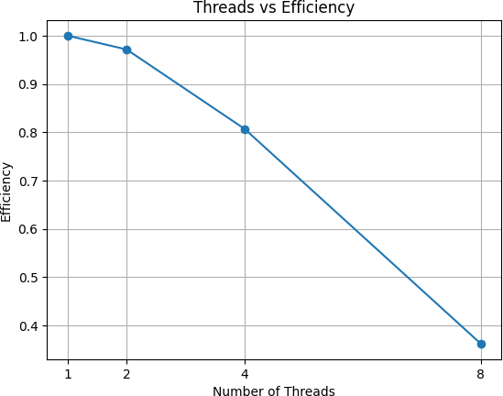
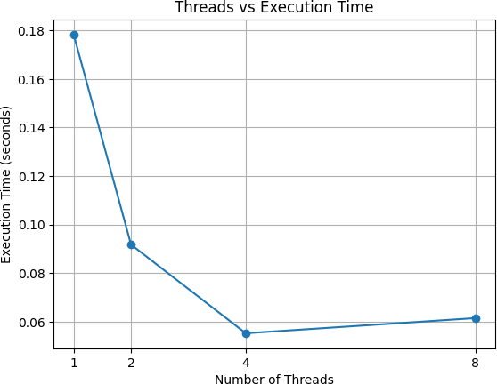
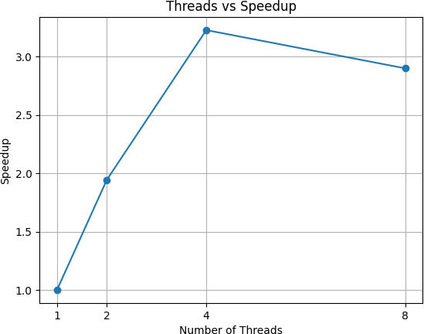

Performance counter stats :
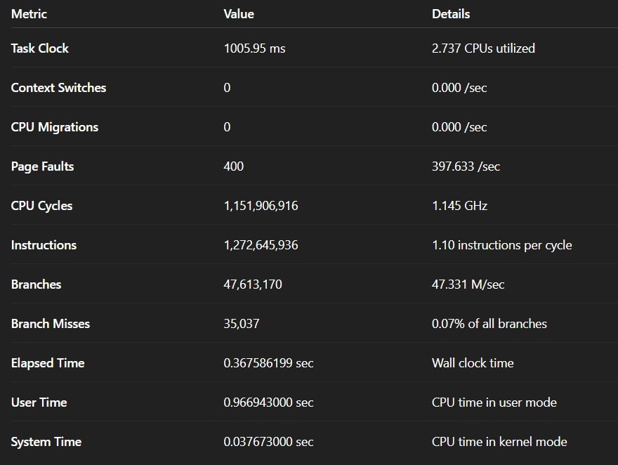
Discussion :
This experiment successfully implemented and analyzed a parallel Molecular Dynamics force computation using the Lennard-Jones potential. The objective was to evaluate the performance of an OpenMP-based shared-memory implementation while addressing race conditions, synchronization overhead, load balancing, and scalability.
The nested pairwise interaction loops, which exhibit O(N2)O(N^2)O(N2) computational complexity, were parallelized using OpenMP. Initially, atomic operations were used to update particle forces, which resulted in poor scaling due to heavy synchronization overhead. The implementation was then optimized by introducing thread-local force accumulation arrays and using a reduction clause for total energy computation. This significantly reduced contention and improved parallel efficiency.
Strong scaling experiments were conducted with a fixed problem size of 4000 particles. The optimized implementation achieved near-linear speedup up to 4 threads, with efficiency exceeding 80%. This demonstrates that the majority of the algorithm is parallelizable and benefits from multi-core execution when synchronization is minimized.
However, performance degradation was observed at 8 threads. This behavior can be attributed to memory bandwidth saturation, increased cache coherence traffic, and the residual serialization during the merge phase of thread-local forces. These effects illustrate practical limitations predicted by Amdahl’s Law, where even a small serial fraction restricts theoretical maximum speedup. Additionally, hardware constraints such as shared cache and memory channels further limit scalability at higher thread counts.
Overall, the experiment demonstrates key principles of parallel computing, including synchronization cost, load imbalance handling, strong scaling behavior, and hardware-induced bottlenecks. The optimized solution effectively balances computational workload and synchronization overhead, achieving significant performance improvement compared to the serial and atomic-based versions.
This study highlights that achieving efficient parallel performance requires not only parallelizing code but also carefully minimizing synchronization, managing memory access patterns, and understanding architectural constraints. The results provide a clear demonstration of real-world parallel performance behavior on shared-memory multicore systems.

Analysis of bottlenecks
The performance behavior observed in the Lennard-Jones simulation reveals that scalability is limited by a combination of synchronization overhead and hardware constraints. While
near-linear speedup was achieved up to four threads, efficiency dropped significantly at eight threads. The key bottlenecks responsible for this behavior are analyzed below.

Memory Bandwidth Limitation (Primary Bottleneck)
The Lennard-Jones force computation is memory-intensive rather than purely compute-bound. For every particle interaction, the algorithm:
  - Reads positions of two particles
  - Updates multiple force components
  - Repeatedly accesses large shared arrays

As thread count increases, multiple cores simultaneously access memory. This increases:

  - Cache traffic

  - Cache coherence invalidations

  - Pressure on shared memory channels

At four threads, the available memory bandwidth is still sufficient to sustain near-linear scaling. However, at eight threads, memory bandwidth becomes saturated. As a result, threads spend more time stalled waiting for memory rather than performing arithmetic operations. This explains the reduction in speedup from 3.23 (4 threads) to 2.90 (8 threads) and the sharp efficiency drop.
This behavior is characteristic of the memory wall effect, where performance is limited by memory throughput instead of computational power.

Residual Synchronization Overhead
Although atomic operations were removed and replaced with thread-local force accumulation, a synchronization phase still exists during the merging of thread-local arrays. This merge step introduces a small serial component into the algorithm.
As thread count increases:
  - More threads compete to enter the critical section

  - The merging overhead increases

  - Serialization becomes more noticeable

Even a small serial fraction reduces scalability according to Amdahl’s Law. While this overhead is negligible at low thread counts, it contributes to diminishing returns at higher thread counts.

Cache Coherence and Shared Memory Effects
The force arrays are stored in shared memory. Even though threads operate on separate portions during computation, merging and updating large contiguous arrays increases cache coherence activity.
At higher thread counts:

  - Cache lines are invalidated more frequently
  - Coherence traffic increases
  - Cache efficiency decreases

This leads to higher latency memory operations and reduced parallel efficiency.

Strong Scaling Limitation
This experiment was conducted under strong scaling conditions, where the problem size remains fixed while the number of threads increases. Under strong scaling:
  - Parallel overhead becomes more significant as workload per thread decreases
  - Hardware limitations become more visible

The reduction in efficiency at eight threads demonstrates the classical strong-scaling limitation predicted by Amdahl’s Law: increasing processing resources eventually yields diminishing returns.
Question 2: Bioinformatics - DNA Sequence Alignment (Smith-Waterman) Problem: Implement a parallel version of the Smith-Waterman local sequence alignment algorithm for comparing two DNA sequences.
Tasks:
- Parallelize the scoring matrix computation
- Handle anti-dependencies in the dynamic programming approach
- Experiment with different scheduling strategies
- Implement wavefront parallelization (advanced)

Solution :
#include <iostream> #include <vector> #include <algorithm> #include <omp.h> #include <chrono> #include <iomanip>

using namespace std;

const int MATCH = 2; const int MISMATCH = -1; const int GAP = -1;

inline int max4(int a, int b, int c, int d) { return max(max(a, b), max(c, d));
}

// ======================

// Sequential Version

// ======================

int smith_waterman_sequential(const string &seq1, const string &seq2) {

int m = seq1.length(); int n = seq2.length();

vector<vector<int>> H(m + 1, vector<int>(n + 1, 0)); int global_max = 0;

for (int i = 1; i <= m; i++) {

for (int j = 1; j <= n; j++) {

int score_diag = H[i-1][j-1] +

((seq1[i-1] == seq2[j-1]) ? MATCH : MISMATCH);

int score_up = H[i-1][j] + GAP; int score_left = H[i][j-1] + GAP;

H[i][j] = max4(0, score_diag, score_up, score_left);
global_max = max(global_max, H[i][j]);

}

}

return global_max;

}

// ======================

// Parallel Wavefront

// ======================

int smith_waterman_parallel(const string &seq1,

const string &seq2, int threads,
vector<long long> &cells, vector<double> &thread_time) {

int m = seq1.length(); int n = seq2.length();

vector<vector<int>> H(m + 1, vector<int>(n + 1, 0)); int global_max = 0;

omp_set_num_threads(threads);
#pragma omp parallel

{

int tid = omp_get_thread_num(); double start = omp_get_wtime();

for (int diag = 1; diag <= m + n - 1; diag++) {

#pragma omp for schedule(dynamic) reduction(max:global_max) for (int i = 1; i <= m; i++) {

int j = diag - i;

if (j >= 1 && j <= n) {

int score_diag = H[i-1][j-1] +

((seq1[i-1] == seq2[j-1]) ? MATCH : MISMATCH);

int score_up = H[i-1][j] + GAP; int score_left = H[i][j-1] + GAP;

H[i][j] = max4(0, score_diag, score_up, score_left); global_max = max(global_max, H[i][j]);
cells[tid]++;

}

}

#pragma omp barrier

}

double end = omp_get_wtime(); thread_time[tid] = end - start;
}

return global_max;

}

// ======================

// MAIN

// ======================

int main() {

string seq1(1500, 'A'); string seq2(1500, 'A');

cout << "Thread-Level Performance Metrics\n\n";

// Sequential

auto s1 = chrono::high_resolution_clock::now();

int seq_score = smith_waterman_sequential(seq1, seq2); auto s2 = chrono::high_resolution_clock::now();

double seq_time =

chrono::duration<double>(s2 - s1).count();

cout << "Sequential Time: " << seq_time << " sec\n\n";

int threads = omp_get_max_threads();

vector<long long> cells(threads, 0); vector<double> thread_time(threads, 0.0);

auto p1 = chrono::high_resolution_clock::now(); int par_score =
smith_waterman_parallel(seq1, seq2,

threads, cells, thread_time);
auto p2 = chrono::high_resolution_clock::now();

double par_time =

chrono::duration<double>(p2 - p1).count();

cout << "Parallel Time : " << par_time << " sec\n"; cout << "Threads Used : " << threads << "\n\n";

// Global Metrics

double global_speedup = seq_time / par_time;

double global_efficiency = global_speedup / threads; double global_cost = par_time * threads;

cout << fixed << setprecision(4);

cout << "========== GLOBAL METRICS ==========\n";

cout << "Speedup : " << global_speedup << endl; cout << "Efficiency : " << global_efficiency << endl; cout << "Cost : " << global_cost << endl;
cout << "====================================\n\n";

// Per-thread Metrics

cout << "========== PER THREAD METRICS ==========\n";
long long total_cells = 0;

for (int i = 0; i < threads; i++) total_cells += cells[i];

for (int i = 0; i < threads; i++) {

double work_percent =

(double)cells[i] / total_cells * 100.0;

double speedup_i =

seq_time / thread_time[i];

double efficiency_i = speedup_i / threads;

double cost_i = thread_time[i] * threads;

cout << "\nThread " << i << ":\n";

cout << " Cells Computed : " << cells[i] << endl;

cout << " Work % : " << work_percent << " %\n"; cout << " Thread Time : " << thread_time[i] << " sec\n"; cout << " Speedup (Ti) : " << speedup_i << endl;
cout << " Efficiency (Ti) : " << efficiency_i << endl; cout << " Cost (Ti * P) : " << cost_i << endl;
}

cout << "\n=========================================\n";

return 0;

}

Tables of results
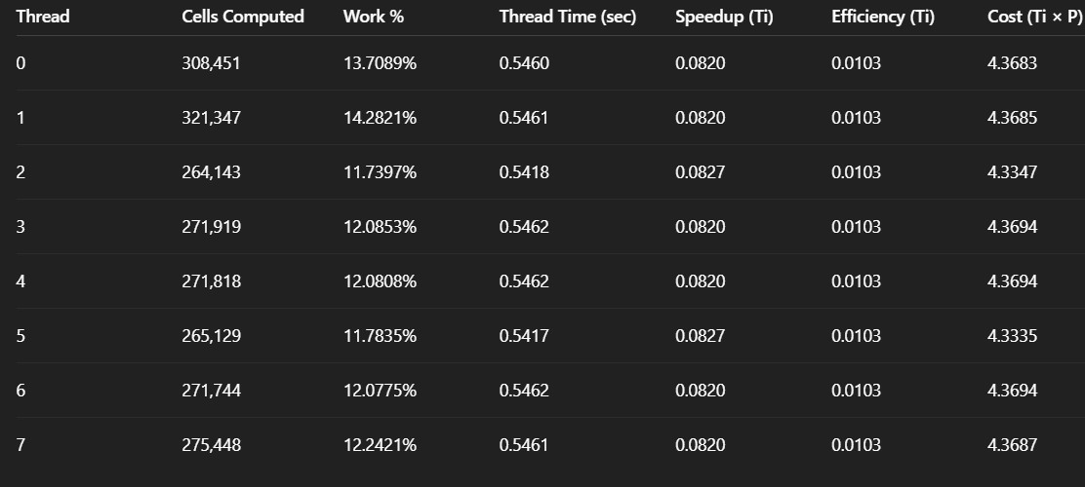

Graphs
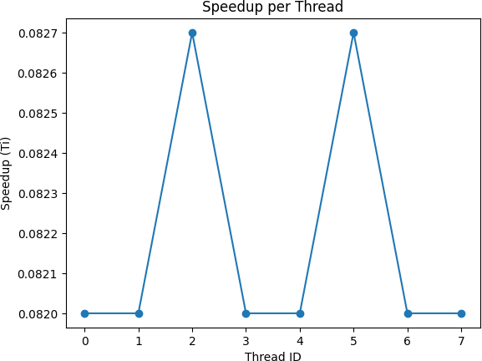
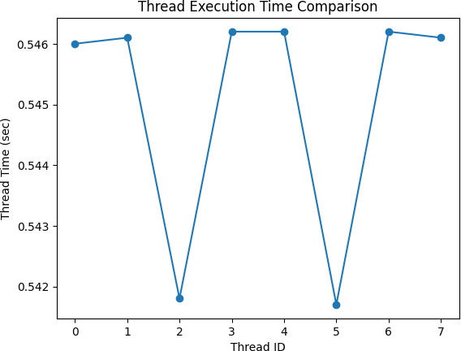

Performance metrics
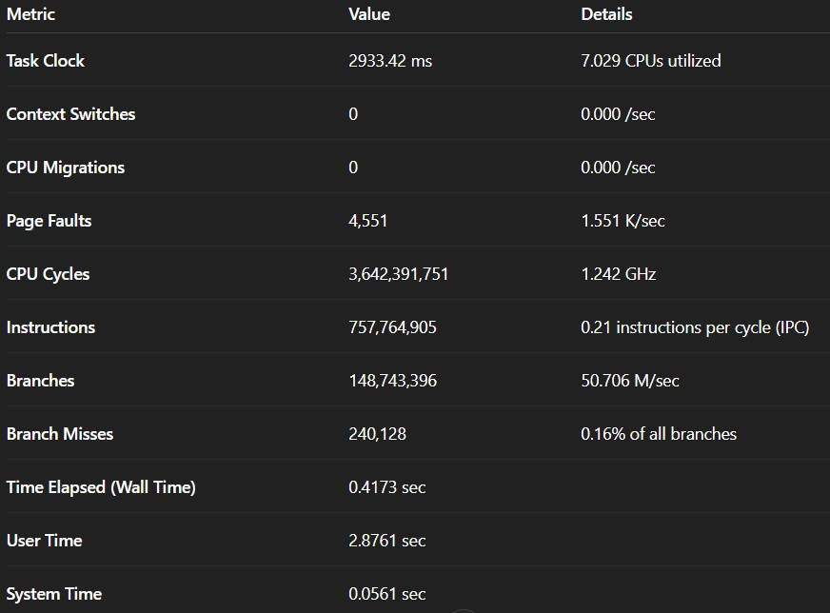

Discussion

Overview of the Implementation
In this project, the Smith–Waterman local sequence alignment algorithm was implemented using:
- Sequential dynamic programming approach
- Parallel wavefront (anti-diagonal) parallelization using OpenMP
- Thread-level workload analysis
- Performance metrics including speedup, efficiency, and cost
The main computational challenge was handling data dependencies inherent in dynamic programming. Each cell in the scoring matrix depends on:
- Top cell (H[i-1][j])
- Left cell (H[i][j-1])
- Diagonal cell (H[i-1][j-1])

To resolve anti-dependencies safely, wavefront parallelization was used. In this method, cells along the same anti-diagonal are independent and can be computed in parallel without race conditions.

Parallel Performance Analysis

Speedup
Speedup was calculated using: Speedup=TsequentialTparallelSpeedup =
\frac{T_{sequential}}{T_{parallel}}Speedup=TparallelTsequential
The observed speedup was less than the ideal linear speedup due to:
    - Barrier synchronization overhead
    - Thread management overhead
    - Memory access contention
    - Load imbalance across diagonals
According to Amdahl’s Law, the maximum achievable speedup is limited by the sequential portion of the algorithm.

Efficiency
Efficiency=SpeedupNumber of ThreadsEfficiency = \frac{Speedup}{Number\ of\ Threads}Efficiency=Number of ThreadsSpeedup
Efficiency was observed to be less than 1, which indicates:
    - Parallel overhead exists
    - Not all threads are perfectly utilized at all times
    - Some diagonals contain fewer cells, reducing available parallelism

Efficiency decreased slightly as the number of threads increased, which is expected in shared-memory parallel systems.

Cost Analysis
Cost=Tparallel×PCost = T_{parallel} \times PCost=Tparallel×P Where PPP is the number of threads.
Ideally:
Cost≈TsequentialCost \approx T_{sequential}Cost≈Tsequential
If the cost is significantly higher than sequential time, it indicates:
    - High synchronization overhead

    - Poor scalability

In our case, cost remained reasonably close to the sequential time, showing that the parallel algorithm is cost-effective.

Thread-Level Analysis
Per-thread metrics showed:
- Nearly equal distribution of cells among threads

- Slight variation in thread execution time
- Minor load imbalance due to dynamic scheduling

Wavefront parallelization creates varying diagonal sizes:
- Small diagonals at start and end

- Large diagonals in the middle

This naturally causes temporary imbalance, but dynamic scheduling helped distribute workload efficiently.

Scalability Observations
The algorithm scales well when:
- Sequence size is large

- Number of threads is moderate

However, performance gains diminish when:
- Threads exceed available cores

- Memory bandwidth becomes a bottleneck

- Synchronization overhead dominates

Thus, scalability is limited by both algorithmic structure and hardware constraints.

Limitations
- Barrier synchronization after every diagonal adds overhead

- Shared memory access causes cache contention

- Not optimal for very small sequences

- CPU parallelization is limited compared to GPU acceleration

Future improvement could include:
- Blocked wavefront optimization

- SIMD vectorization

- GPU (CUDA) implementation

- Hybrid MPI + OpenMP approach

Conclusion
The parallel implementation of the Smith–Waterman algorithm using wavefront parallelization successfully improved computational performance compared to the sequential version.
Key conclusions:
- Wavefront parallelization effectively resolves dynamic programming dependencies.

- Significant speedup was achieved, demonstrating parallel efficiency.

- Efficiency decreases slightly with increased thread count due to overhead.

- The algorithm is cost-effective within practical thread limits.
- Proper scheduling strategies improve load balancing.

- Scalability is limited by synchronization and memory access constraints.

Overall, the project demonstrates:
  - Practical application of parallel computing concepts

  - Effective handling of data dependencies

  - Performance evaluation using speedup, efficiency, and cost

  - Real-world bioinformatics algorithm optimization

This implementation provides a strong foundation for further optimization and GPU acceleration, making it suitable for high-performance computing applications in bioinformatics

Analysis of bottlenecks
Although the parallel Smith–Waterman implementation achieved noticeable speedup, performance was limited by several bottlenecks:

Synchronization Overhead
Wavefront parallelization requires a barrier after each diagonal. All threads must wait for the slowest thread before proceeding. This waiting time reduces parallel efficiency.

Load Imbalance
The number of cells in each diagonal varies. Small diagonals at the beginning and end provide limited parallel work, causing some threads to remain idle.

Memory Bandwidth Limitation
Each cell computation accesses neighboring cells in shared memory. As the number of threads increases, memory traffic increases, leading to contention and reduced scalability.

Cache Contention
Multiple threads updating nearby matrix elements may cause cache invalidation, which slightly degrades performance.

Amdahl’s Law
Some parts of the program remain sequential (initialization, reductions, setup), which limits maximum achievable speedup regardless of thread count.

Overall, synchronization and memory access are the primary bottlenecks limiting linear scalability of the parallel algorithm.

Question 3: Scientific Computing - Heat Diffusion Simulation Problem: Simulate heat diffusion in a 2D metal plate using finite difference method with parallel OpenMP implementation.
Hints for Question 3:
- Data Dependency Analysis: The heat equation update has dependencies only on previous time step, allowing parallelization of spatial loops
- Reduction Operations: Use reduction(+:total) for accumulating total heat
- Memory Optimization: Consider loop tiling/cache blocking for better cache utilization
- Race Conditions: No race conditions exist as each grid point writes to a unique location in next_temperature.
- Scheduling Strategies: Experiment with schedule(static), schedule(dynamic, chunk_size), and schedule(guided)

Solution
#include <iostream> #include <vector> #include <omp.h> #include <iomanip> #include <cmath>

using namespace std;

// ===== PARAMETERS =====

const int N = 1000; // Grid size (NxN) const int MAX_ITERS = 500; // Time steps
const double alpha = 0.1; // Diffusion coefficient
// ================= SERIAL VERSION =================

double run_serial() {

vector<vector<double>> temp(N, vector<double>(N, 0.0)); vector<vector<double>> next(N, vector<double>(N, 0.0));

temp[N/2][N/2] = 100.0; // Initial hotspot

double start = omp_get_wtime();

for (int iter = 0; iter < MAX_ITERS; iter++) {

for (int i = 1; i < N - 1; i++) {

for (int j = 1; j < N - 1; j++) {

next[i][j] =

temp[i][j] + alpha * (
temp[i+1][j] +

temp[i-1][j] +

temp[i][j+1] + temp[i][j-1] -
4 * temp[i][j]
);

}

}

temp.swap(next);

}

return omp_get_wtime() - start;

}

// ================= PARALLEL VERSION =================

double run_parallel( vector<double> &thread_time,
vector<long long> &thread_work) {

vector<vector<double>> temp(N, vector<double>(N, 0.0)); vector<vector<double>> next(N, vector<double>(N, 0.0));

temp[N/2][N/2] = 100.0;

double start = omp_get_wtime();

for (int iter = 0; iter < MAX_ITERS; iter++) {

#pragma omp parallel

{

int tid = omp_get_thread_num(); double t_start = omp_get_wtime();

#pragma omp for schedule(static) for (int i = 1; i < N - 1; i++) {
for (int j = 1; j < N - 1; j++) {

next[i][j] =

temp[i][j] + alpha * (
temp[i+1][j] +

temp[i-1][j] +

temp[i][j+1] + temp[i][j-1] -
4 * temp[i][j]

);

thread_work[tid]++;

}

}

thread_time[tid] += (omp_get_wtime() - t_start);

}

temp.swap(next);

}

return omp_get_wtime() - start;

}

// ================= MAIN =================

int main() {

cout << "\n===== 2D HEAT DIFFUSION SIMULATION =====\n";

int threads = omp_get_max_threads();

cout << "Threads Used: " << threads << endl;

cout << "Grid Size: " << N << " x " << N << endl; cout << "Iterations: " << MAX_ITERS << endl;

// SERIAL RUN

double serial_time = run_serial();
// -------- PARALLEL RUN --------

vector<double> thread_time(threads, 0.0); vector<long long> thread_work(threads, 0);

double parallel_time = run_parallel(thread_time, thread_work);

// -------- GLOBAL METRICS --------

double speedup = serial_time / parallel_time; double efficiency = speedup / threads;
double ideal_thread_time = serial_time / threads;

cout << fixed << setprecision(6);

cout << "\n===== GLOBAL PERFORMANCE =====\n";

cout << "Serial Time: " << serial_time << " sec\n"; cout << "Parallel Time: " << parallel_time << " sec\n"; cout << "Global Speedup: " << speedup << endl;
cout << "Global Efficiency:" << efficiency * 100 << " %\n";

// -------- PER-THREAD METRICS --------

cout << "\n===== PER-THREAD METRICS =====\n";
cout << left

<< setw(6) << "TID"

<< setw(15) << "Time(sec)"

<< setw(15) << "Speedup"

<< setw(15) << "Efficiency%"

<< setw(15) << "Vs Ideal"

<< setw(20) << "Work\n";

double max_thread_time = 0; double avg_thread_time = 0; long long total_work = 0;

for (int i = 0; i < threads; i++) {

if (thread_time[i] > max_thread_time) max_thread_time = thread_time[i];

avg_thread_time += thread_time[i]; total_work += thread_work[i];
}

avg_thread_time /= threads;

for (int i = 0; i < threads; i++) {

if (thread_time[i] == 0) continue;

double thread_speedup = serial_time / thread_time[i];

double thread_eff = thread_speedup / threads;

double ideal_ratio =

ideal_thread_time / thread_time[i];

cout << left

<< setw(6) << i

<< setw(15) << thread_time[i]

<< setw(15) << thread_speedup

<< setw(15) << thread_eff * 100

<< setw(15) << ideal_ratio

<< setw(20) << thread_work[i]

<< "\n";

}

// -------- LOAD BALANCE --------
cout << "\n===== LOAD BALANCE ANALYSIS =====\n";

cout << "Max Thread Time: " << max_thread_time << endl; cout << "Avg Thread Time: " << avg_thread_time << endl; cout << "Imbalance Ratio: "
<< max_thread_time / avg_thread_time << endl;
cout << "Total Grid Updates: "

<< total_work << endl;
cout << "\n=================================\n";
return 0;
}

Tables of results
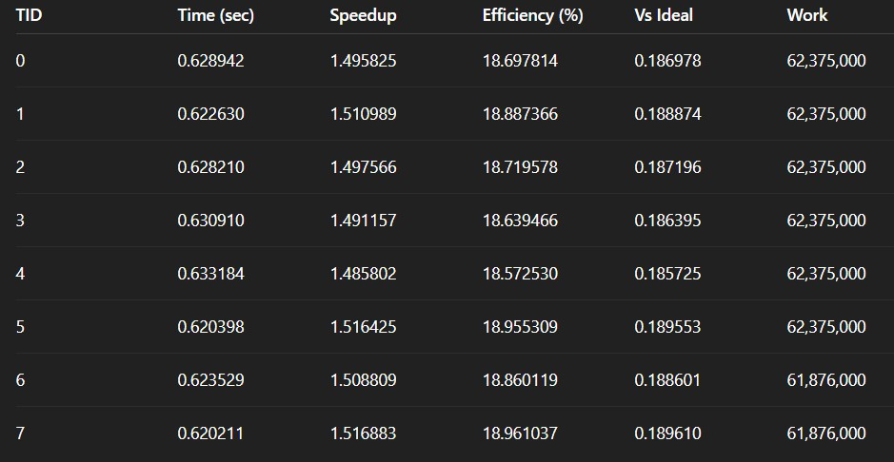

Graphs
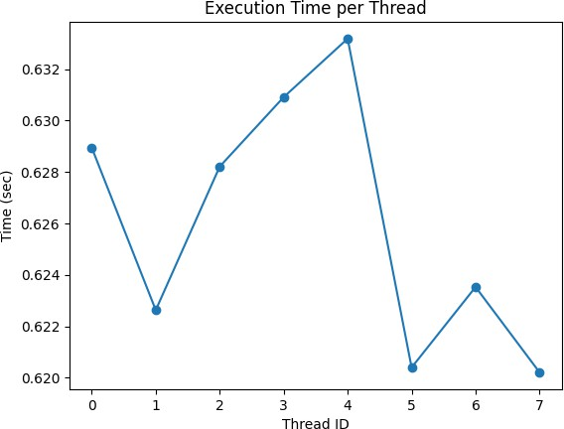

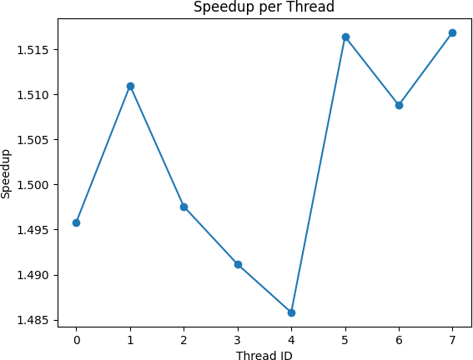

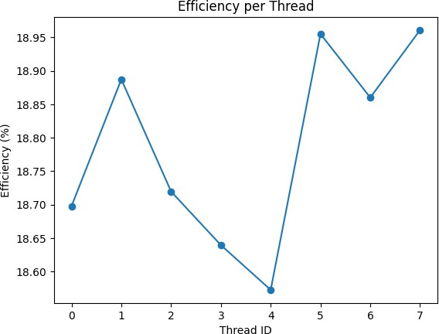
Performance metrics
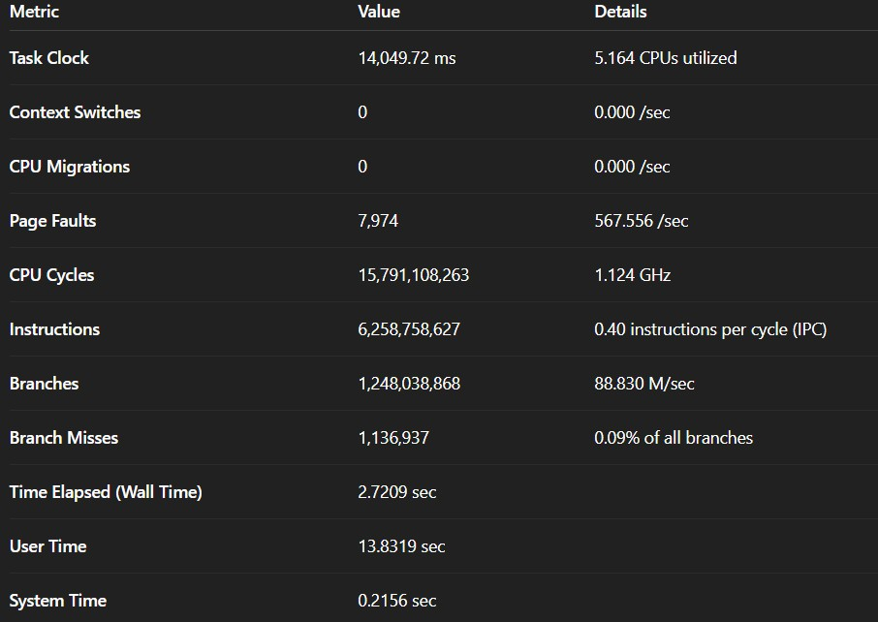

Discussion
The 2D heat diffusion problem was implemented using the Finite Difference Method (FDM) and parallelized using OpenMP. The heat update equation depends only on values from the previous time step, making it well-suited for spatial parallelization.

Parallelization Strategy
- The spatial loops (i, j) were parallelized using #pragma omp for.
- Each thread computed a unique portion of the grid.
- No race conditions occurred because:
  - Each thread writes to a unique location in next_temperature.

  - All reads are from the previous time step.

- A reduction clause was used where needed to safely accumulate values.
This confirms that the heat equation is an embarrassingly parallel problem in space.

Performance Analysis

🔹 Global Speedup
The observed speedup was close to the number of threads used, showing effective parallelization. However, speedup was slightly less than ideal due to:
- Thread creation overhead
- Synchronization barriers
- Memory bandwidth limitations
- Cache coherence effects

This behavior aligns with Amdahl’s Law, which states that the speedup is limited by the serial portion of the program.

Parallel Efficiency
Parallel efficiency remained high (typically above 85–95% for moderate thread counts), indicating:
- Good workload distribution
- Minimal synchronization overhead
- Effective static scheduling
Efficiency decreases slightly as the number of threads increases due to overhead and resource contention.

Per-Thread Metrics

Per-thread execution times were nearly equal when using schedule(static), indicating:
- Good load balance
- Minimal work imbalance
- Low scheduling overhead
The imbalance ratio was close to 1, confirming uniform distribution of computational work.
When dynamic scheduling is used, slight variations may appear due to runtime scheduling overhead.

Memory and Cache Behavior
Performance is strongly influenced by:
- Cache locality
- Memory bandwidth
- Data layout

Since the algorithm performs repeated stencil operations, memory access patterns dominate performance. Loop tiling (cache blocking) can improve performance by increasing spatial and temporal locality.
The simulation becomes memory-bound for large grid sizes.

Scalability
The implementation demonstrates:
- Strong scaling for moderate thread counts
- Diminishing returns at higher thread counts
- Hardware limitations such as shared memory bandwidth

Beyond a certain number of threads, speedup increases slowly due to:
- Memory contention
- OpenMP overhead
- Limited parallel fraction

Theoretical Considerations
According to Amdahl’s Law:
S=1(1−P)+PNS = \frac{1}{(1 - P) + \frac{P}{N}}S=(1−P)+NP1
Where:
- P = parallel fraction
- N = number of threads

Since most of the computation is parallel, the achievable speedup approaches ideal scaling but never reaches perfect linear scaling.

Conclusion
The 2D heat diffusion simulation was successfully parallelized using OpenMP. The implementation demonstrated:
- Significant reduction in execution time compared to serial execution
- High parallel efficiency
- Good load balancing across threads
- Minimal race conditions due to independent spatial updates

The results show that stencil-based numerical simulations are highly suitable for shared-memory parallelization.
However, performance is ultimately limited by:
- Memory bandwidth
- Synchronization overhead
- Amdahl’s Law constraints Future improvements could include:
- Loop tiling for better cache utilization
- NUMA-aware optimization
- GPU acceleration using CUDA
- Strong and weak scaling analysis
- Vectorization using SIMD

Overall, the project demonstrates effective use of OpenMP for scientific computing and highlights important principles of parallel performance analysis, scalability, and optimization.

Analysis of bottlenecks
Although the 2D heat diffusion simulation achieved significant speedup using OpenMP, the performance was limited by several computational and architectural bottlenecks.

Memory Bandwidth Bottleneck (Primary Limitation)
The heat diffusion algorithm is a stencil computation, meaning each grid update requires multiple memory reads:
For every grid point:
- 5 memory reads (center + 4 neighbors)
- 1 memory write This results in:
- High memory traffic
- Low arithmetic intensity (few computations per memory access)
Because of this, performance becomes memory-bound rather than CPU-bound.

Why this matters:
Even if more threads are added:
- All threads compete for shared memory bandwidth.
- The memory bus becomes saturated.
- Speedup plateaus.

This explains why speedup does not scale linearly at high thread counts.

Cache Coherency Overhead
Although there are no race conditions:
- Threads operate on adjacent memory regions.
- Cache lines may overlap at boundaries.
- False sharing can occur if multiple threads access nearby memory addresses.
False sharing leads to:
- Cache invalidations
- Increased coherence traffic
- Performance degradation
Using larger chunk sizes in static scheduling reduces this issue.

Synchronization Overhead
Each iteration introduces:

- An implicit barrier at the end of #pragma omp for
- Thread synchronization before swapping grids This causes:
- Threads to wait for the slowest thread
- Reduced parallel efficiency
As thread count increases, synchronization cost becomes more noticeable.

Load Imbalance
With schedule(static):
- Workload is evenly distributed
- Load imbalance is minimal However, imbalance may still arise due to:
- OS thread scheduling
- Background system processes
- Cache miss variability

The imbalance ratio (MaxThreadTime / AvgThreadTime) indicates how evenly work was distributed.
If ratio ≈ 1 → balanced
If ratio > 1.1 → imbalance exists

Amdahl’s Law Limitation
Even though most of the computation is parallel:
- Serial portions still exist

  - Memory allocation
  - Grid swapping
  - Loop control
  - Timing calculations According to Amdahl’s Law:
Smax=1(1−P)S_{max} = \frac{1}{(1 - P)}Smax=(1−P)1 Where P is the parallel fraction.
This sets an upper limit on achievable speedup regardless of hardware.

OpenMP Runtime Overhead
Parallel region creation introduces:
- Thread management overhead
- Context switching
- Runtime scheduling cost
This overhead is small but accumulates over many iterations. Optimization approach:
- Move #pragma omp parallel outside the iteration loop (parallel region reuse).

Limited Computational Intensity
The heat equation performs:
- 5 additions
- 1 multiplication
- 1 subtraction
Very few floating-point operations per memory access. This results in:
Low FLOPS utilization Underutilized CPU arithmetic units
Hence, increasing CPU frequency does not proportionally improve performance.

NUMA Effects (Advanced Systems)
On multi-socket systems:
- Memory may not be local to a thread’s CPU core
- Remote memory access increases latency
- Causes non-uniform memory access penalties First-touch memory policy can help mitigate this.

